Application:
Clone the below mentioned repository and deploy the application (Run application in port 3000).
Repo URL : https://github.com/Vennilavanguvi/Brain-Tasks-App.git

Repo url – cloned to git hub repository
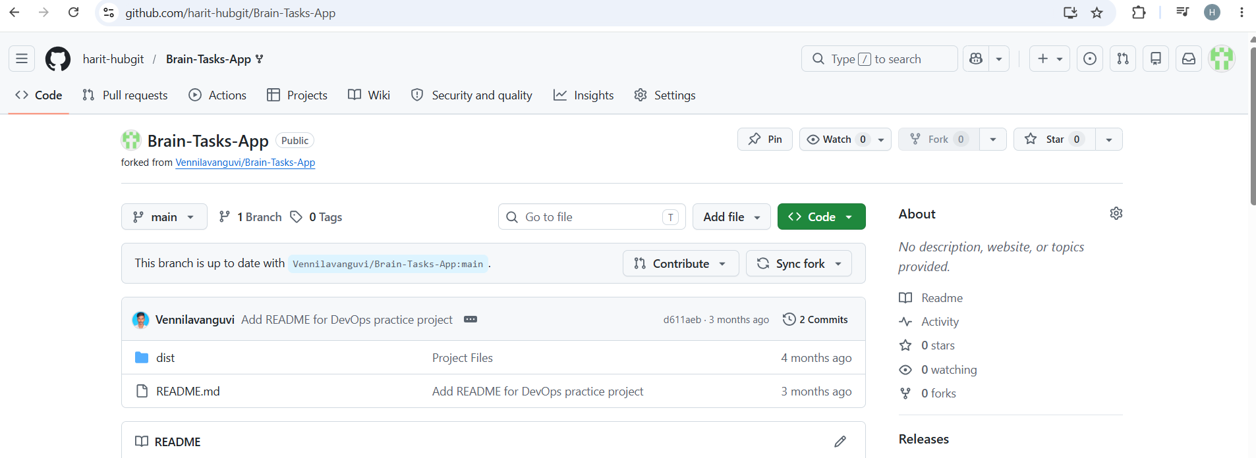

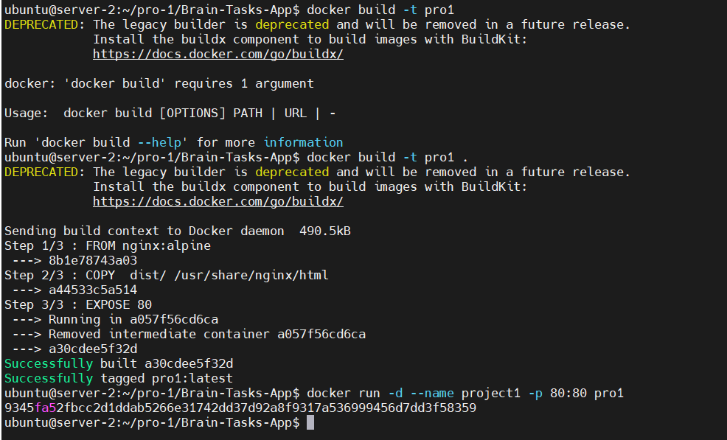
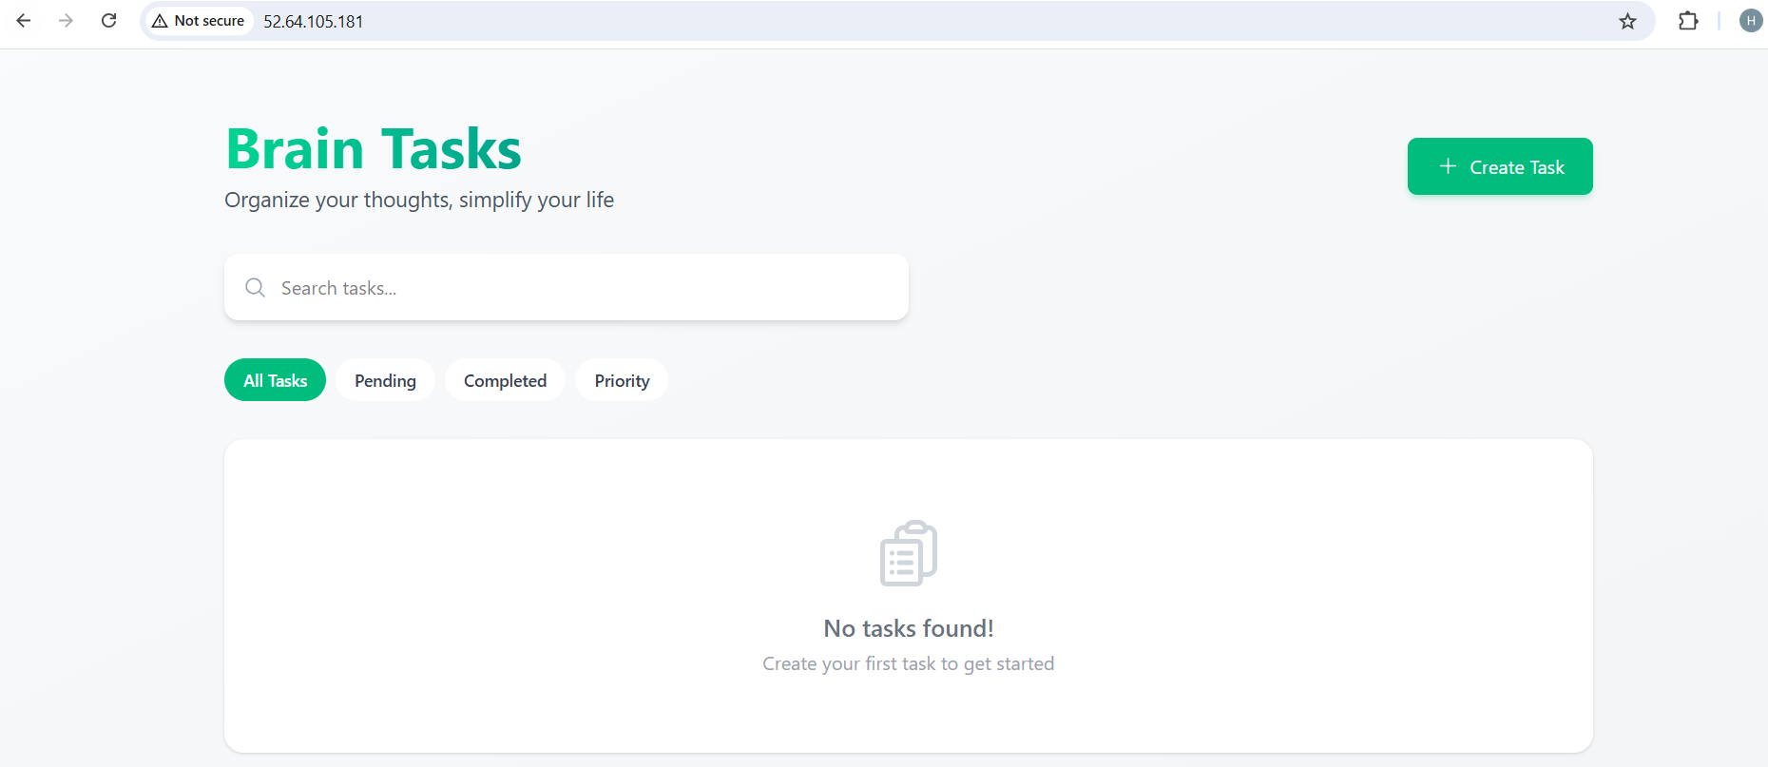

Docker:
- Dockerize the application by creating Dockerfile
- Build an application and check output using docker image.

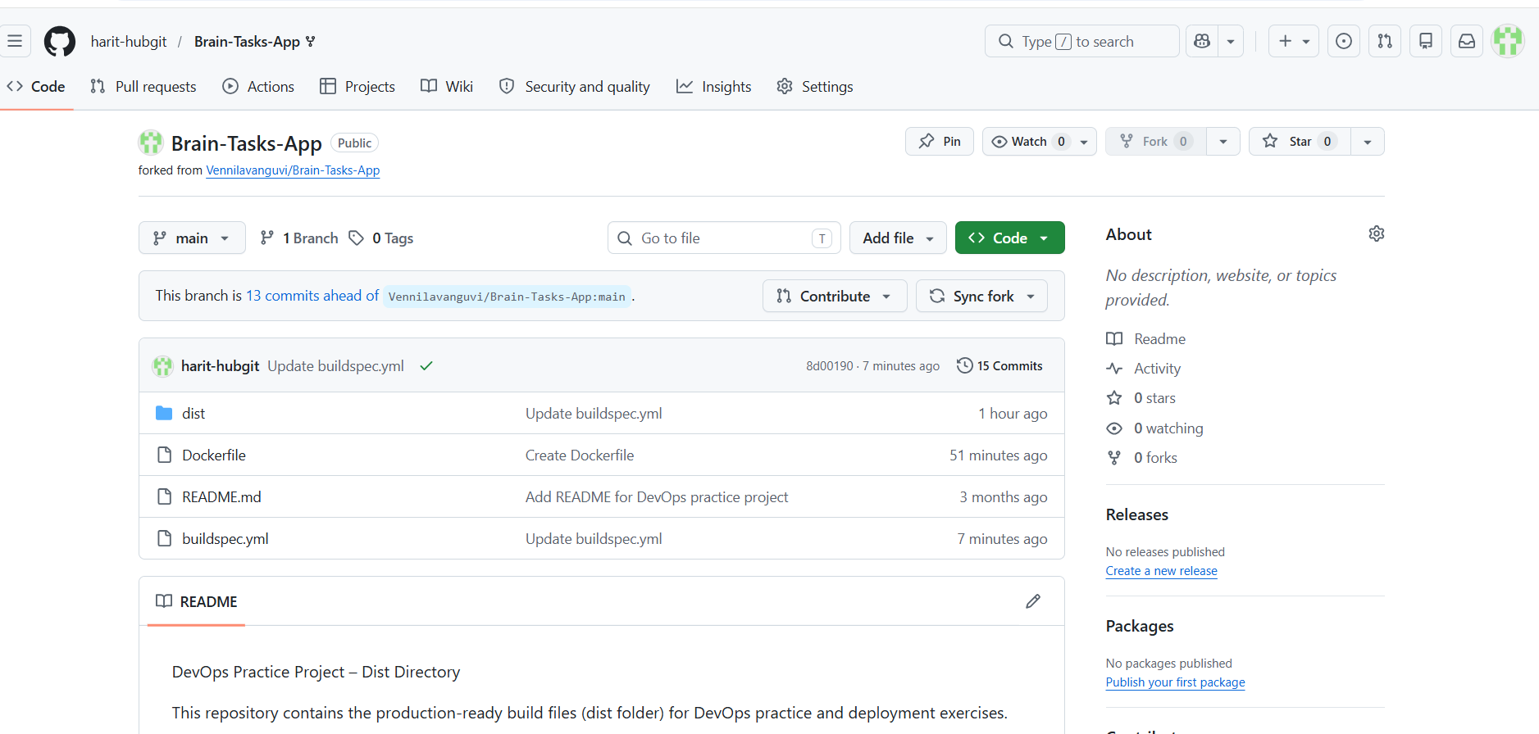

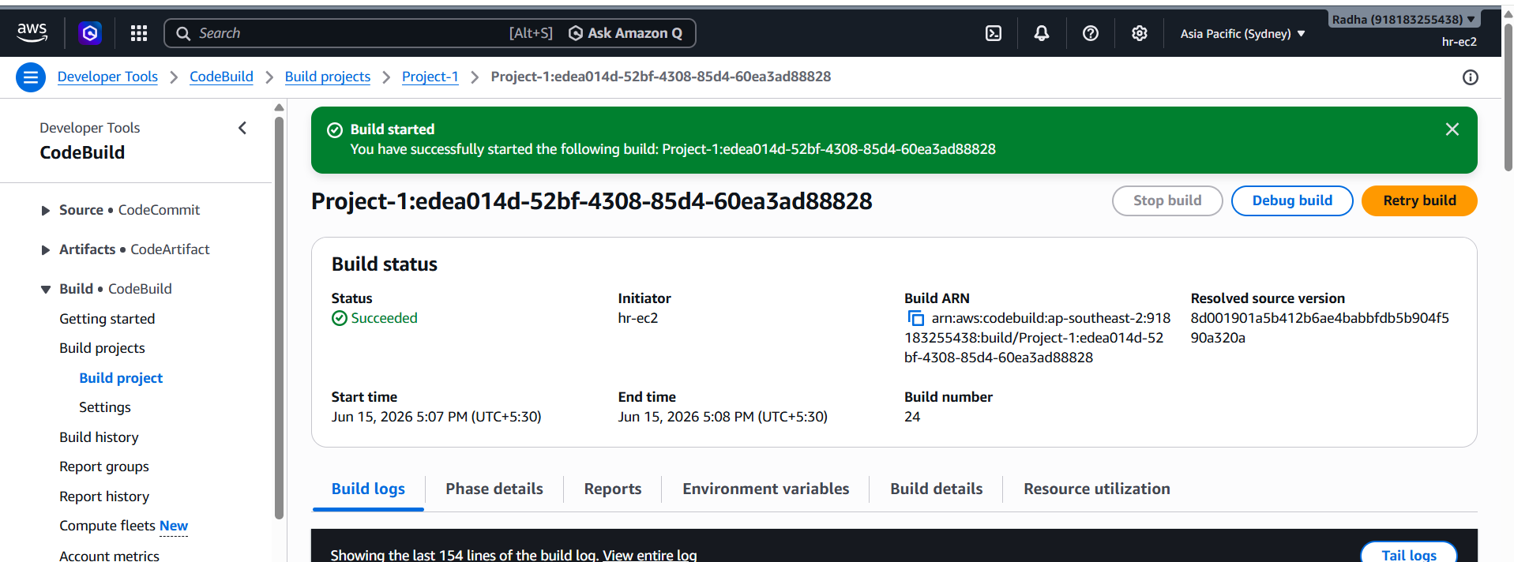

Registry:
- Create an AWS ECR or Dockerhub repository for storing docker images.
- Pushed image to dockerhub repository

Kubernetes:
- Setup Kubernetes in AWS EKS and Confirm EKS cluster is running.
- Write deployment and service YAML files.
- Deploy using kubectl via CodeBuild or Codepipeline.
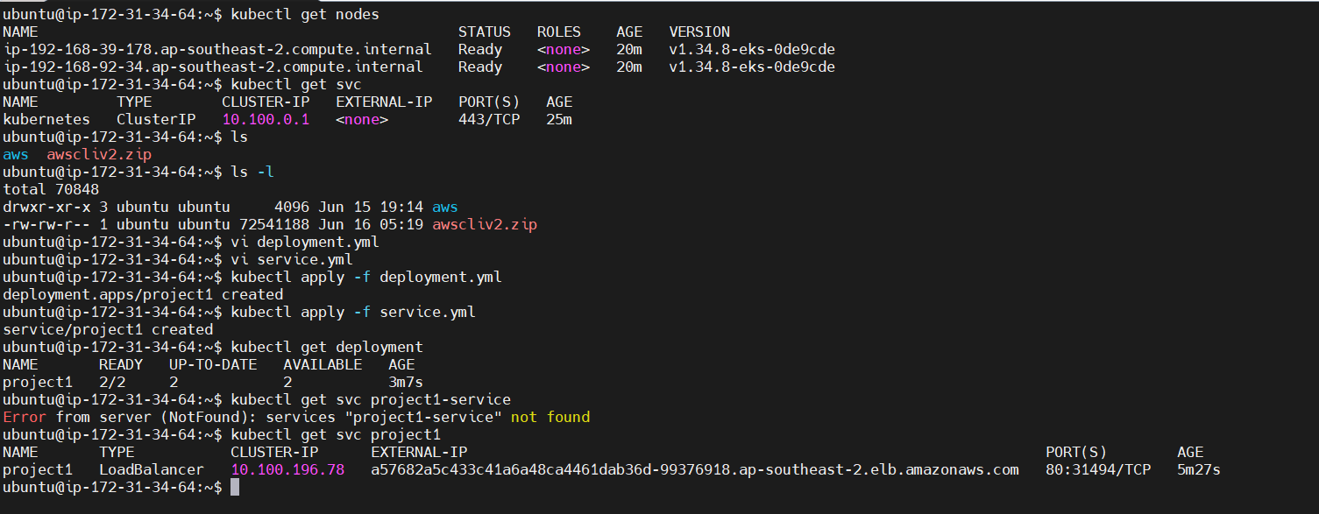
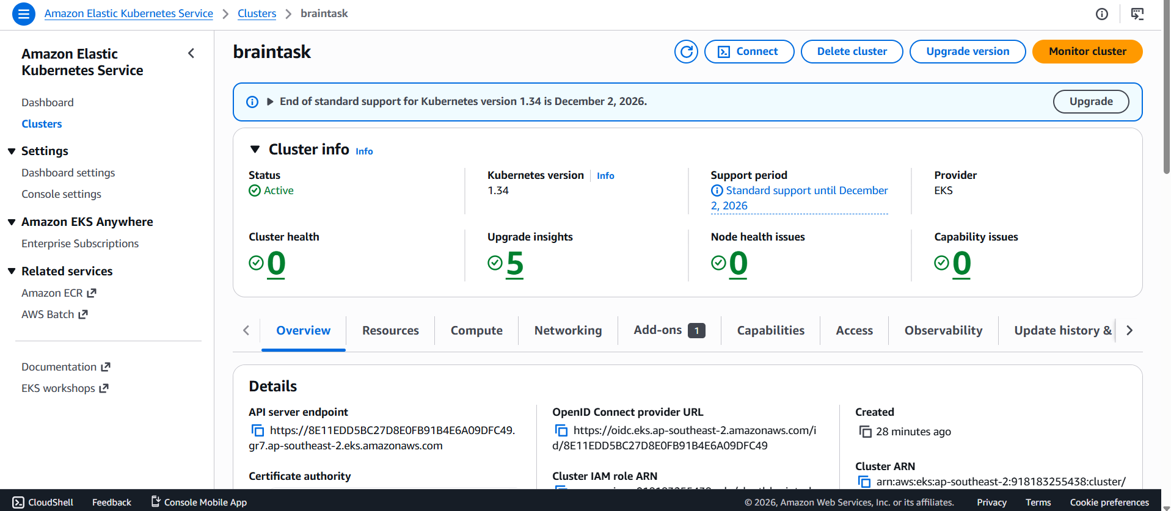
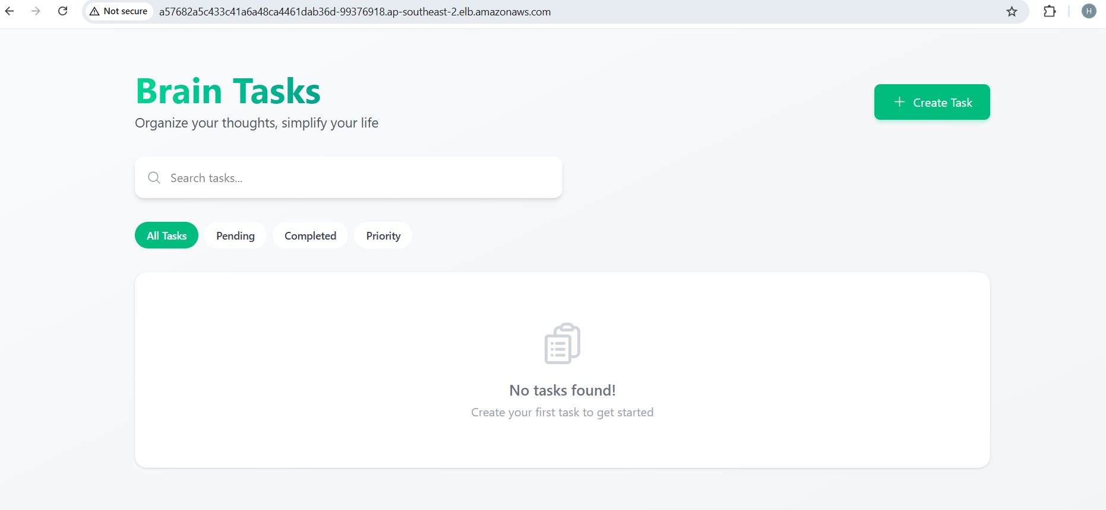
CodePipeline:
- Source: GitHub
- Build: AWS CodeBuild project
- Deploy: Deploy to EKS via Codepipeline EKS deploy stage..

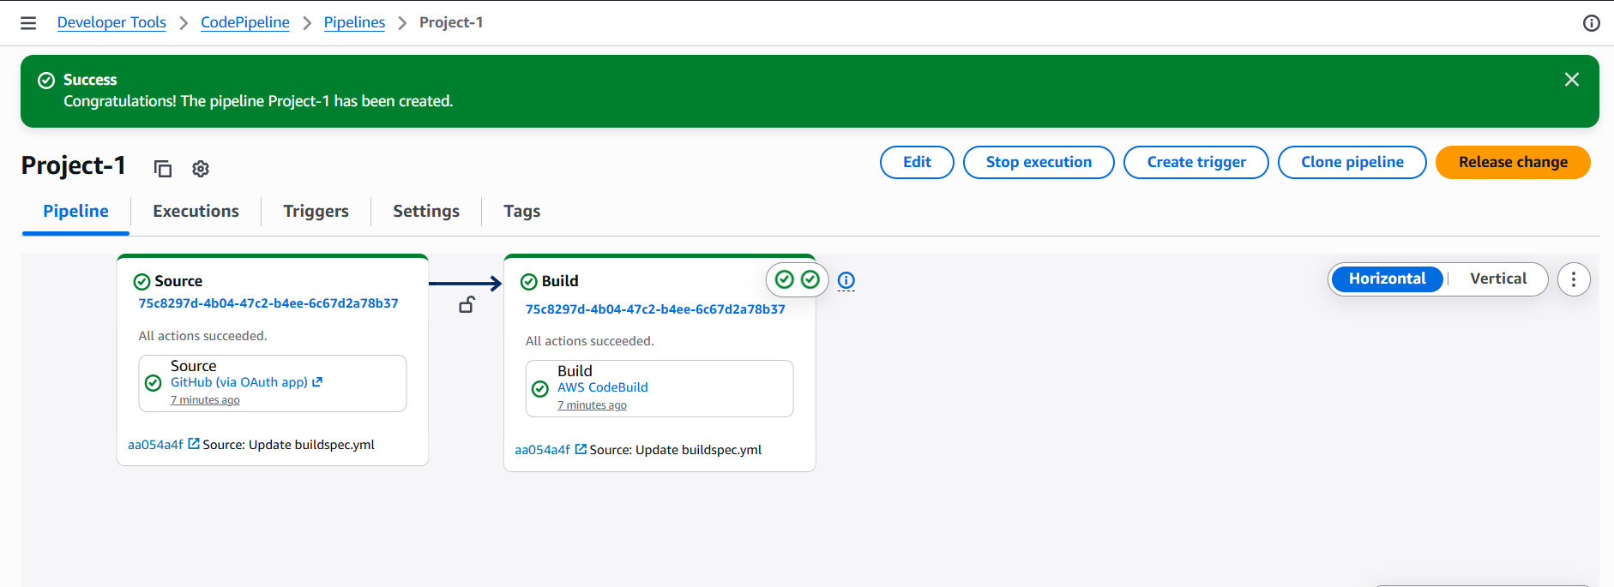
Monitoring:
- Use CloudWatch Logs to track build, deploy, and application logs.

